**Rokomari.com**

**Issue-01:** Invalid Email address format

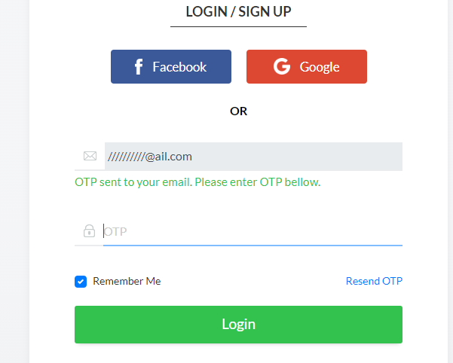



**Description:**

1. Open the site with <https://www.rokomari.com/book>
2. Click on Sign in (It will open **LOGIN / SIGN UP** form)
3. Write down the email with invalid format and it takes as a proper format so bug is found here

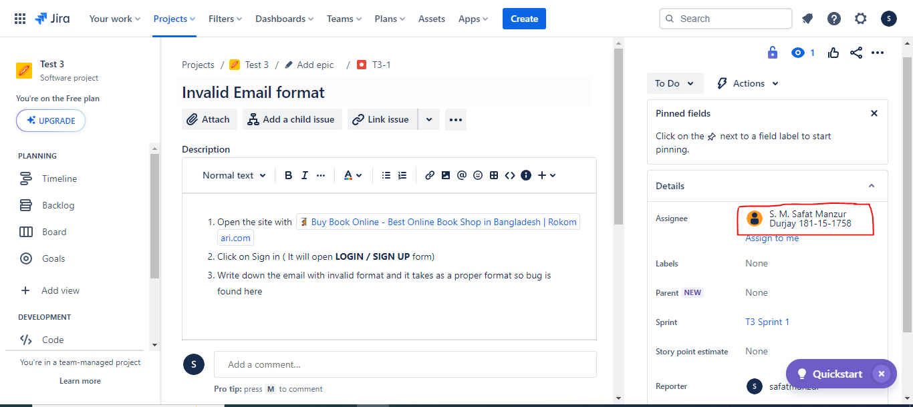

**Description:** The work is assigned to **S. M. Safat Manzur Durjay** for solving the problem.

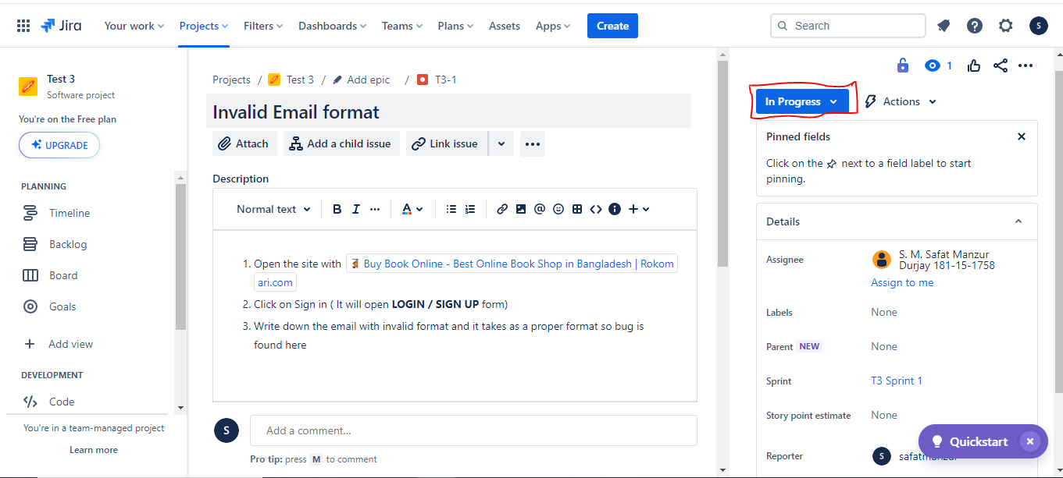

**Description:** The developer starts working on it and it was **In Progress** stage.

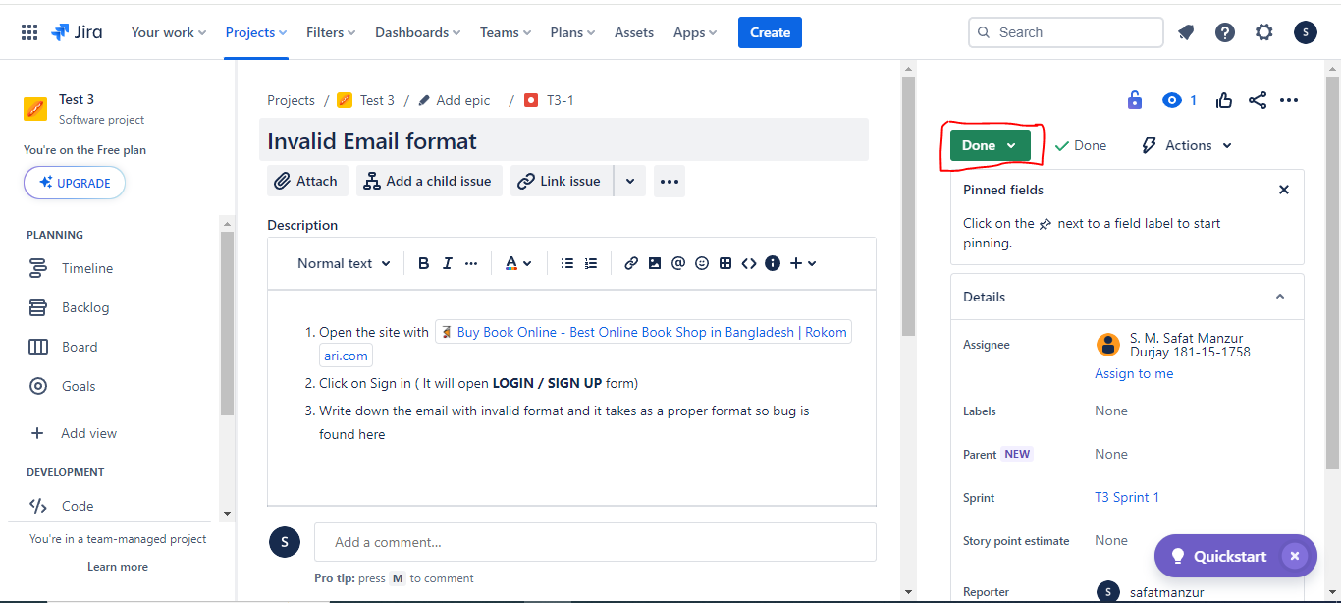

**Description:** The developer completed the work and the work has been **Done**.

**Issue-02:** **Remember Me** checkbox should be uncheck in Login

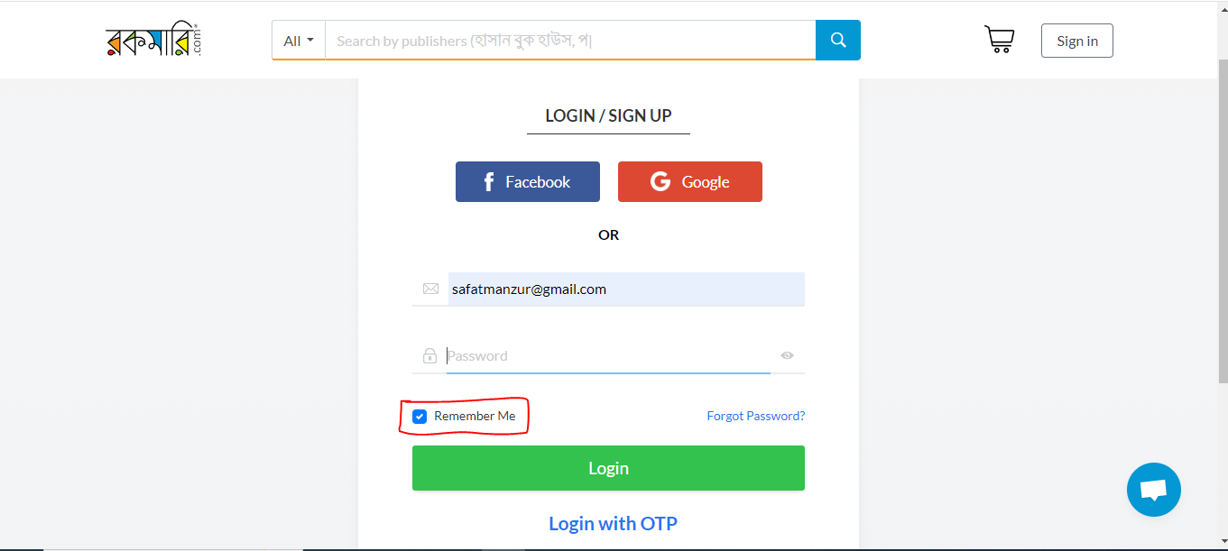

**Description:**

1. Go to the site by searching <https://www.rokomari.com/book>
2. Click on Sign in button
3. Enter valid email and click on **Next** button
4. Then bug will be visible of seeing **Remember Me** checkbox is checked default and it will be a bug

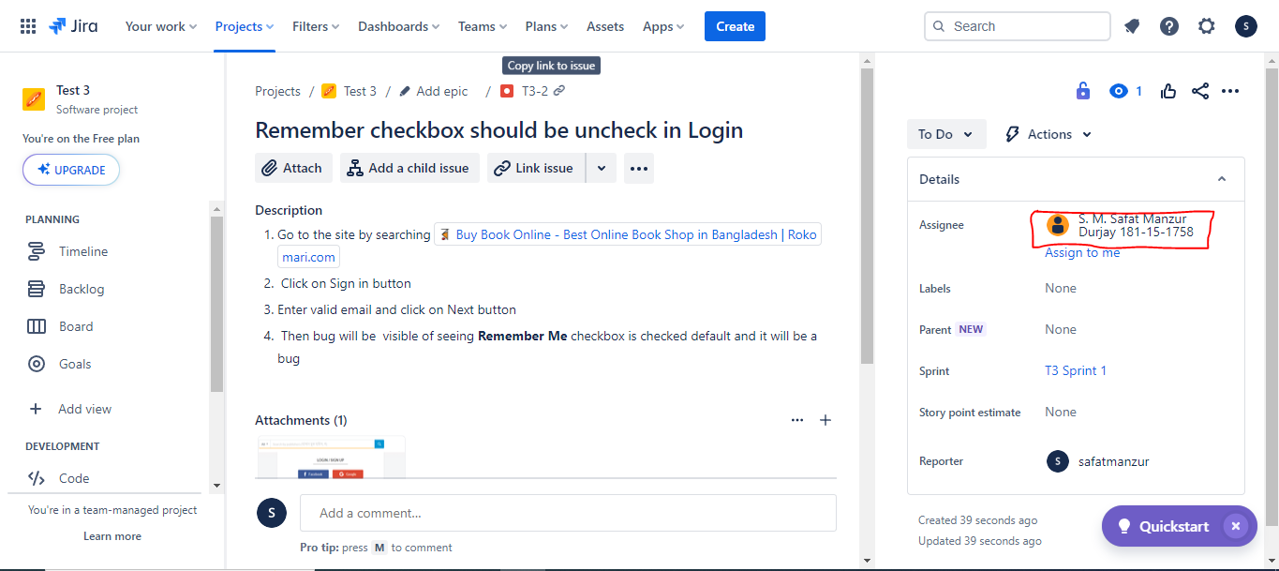

**Description:** The work is assigned to **S. M. Safat Manzur Durjay** for solving the problem.

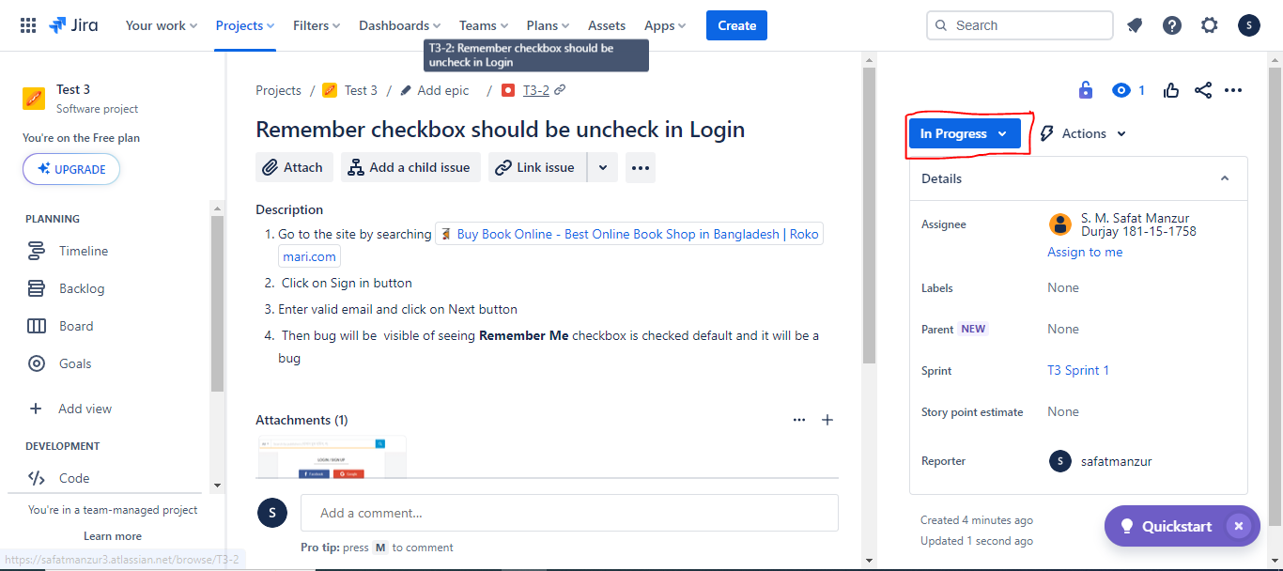

**Description:** The developer started working on it and it was **In Progress** stage.

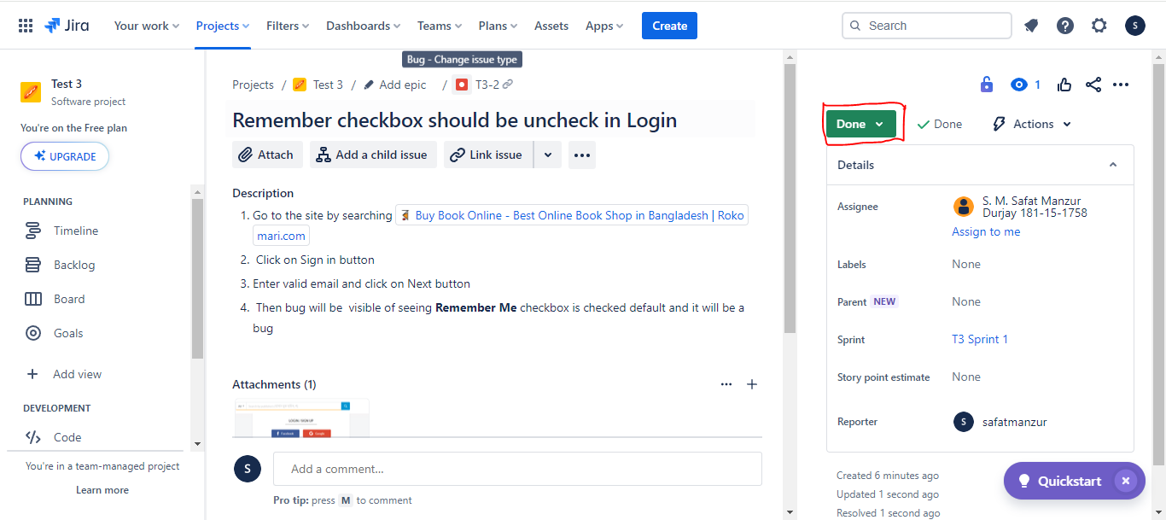

**Description:** The developer completed the work and the work has been done.

**Issue-03:** SIGN UP functionality doesn’t work

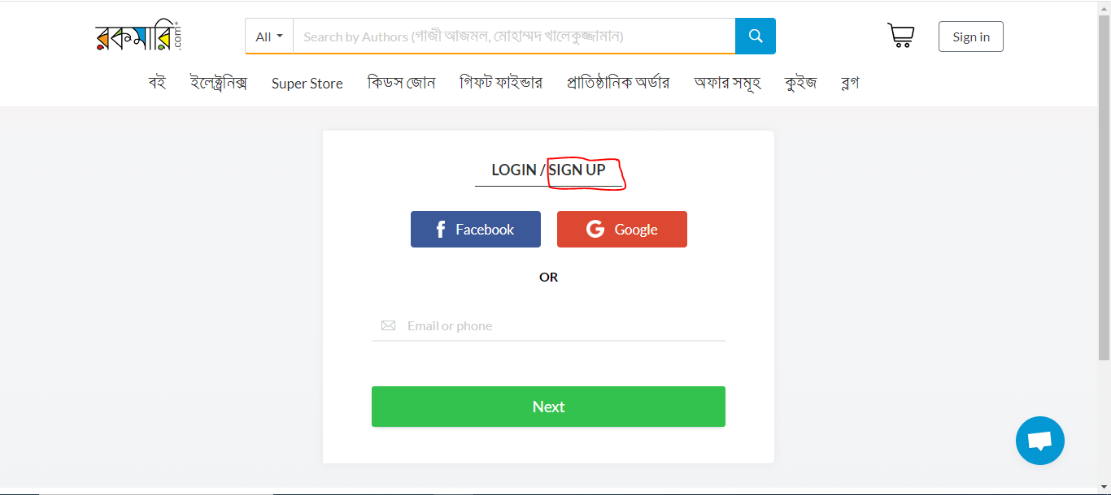

**Description:**

1. Go to website by searching <https://www.rokomari.com/book>
2. Click on Sign in button
3. Try to click on SIGN UP but it actually didn’t work so It’s a bug

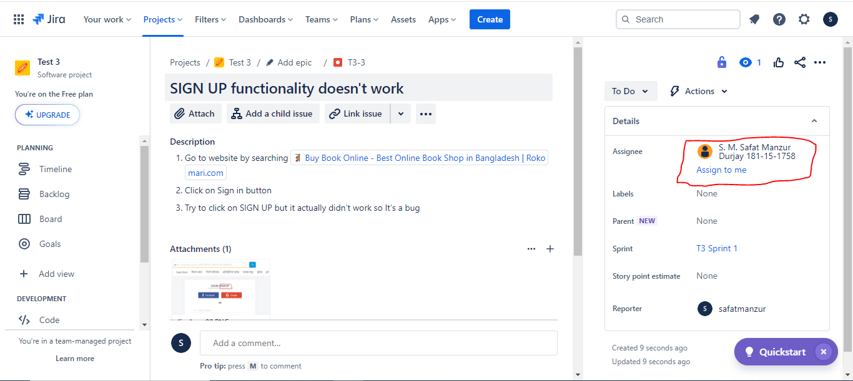

**Description:** The work is assigned to S. M. Safat Manzur Durjay for solving the problem.

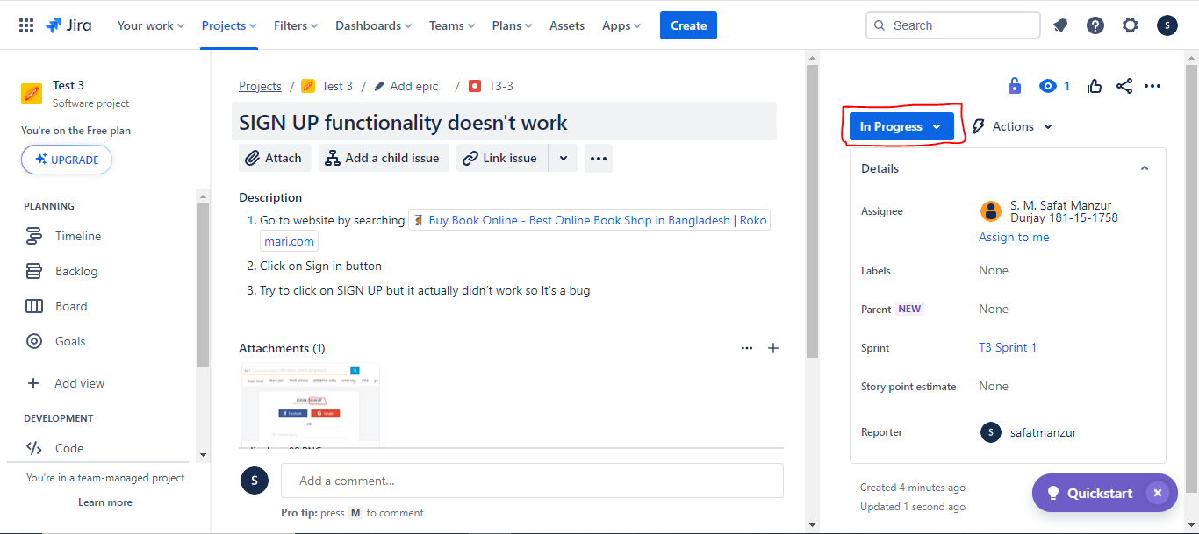

**Description:** The developer started working on it and it was **In Progress** stage.

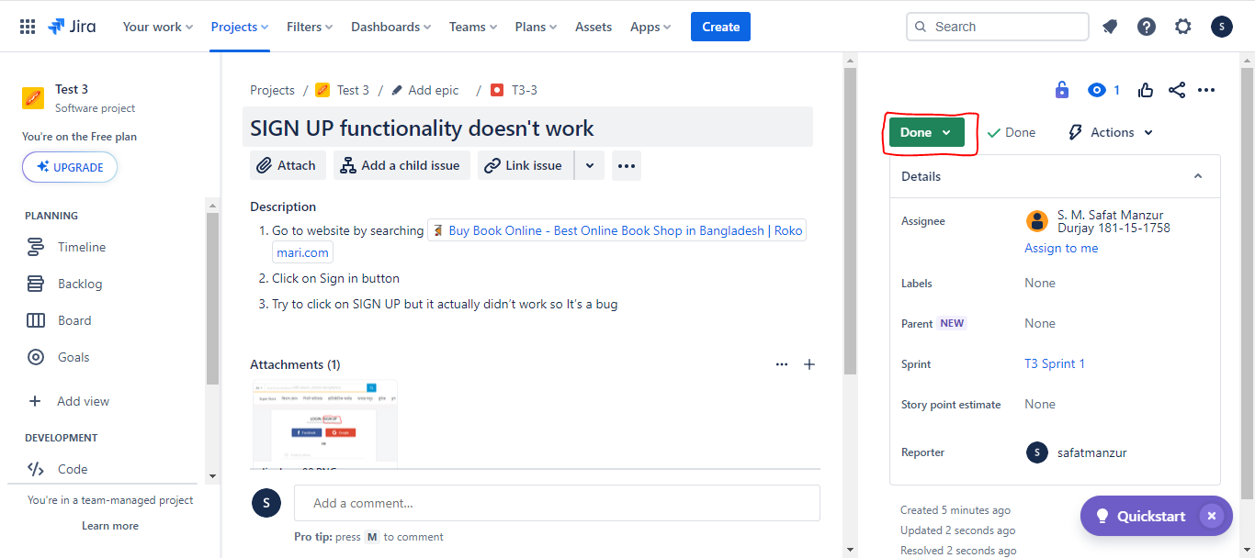

**Description:** The developer completed the work and the work has been **Done**.

**Issue-04:** The website has been suspended and the relevant things didn’t visible

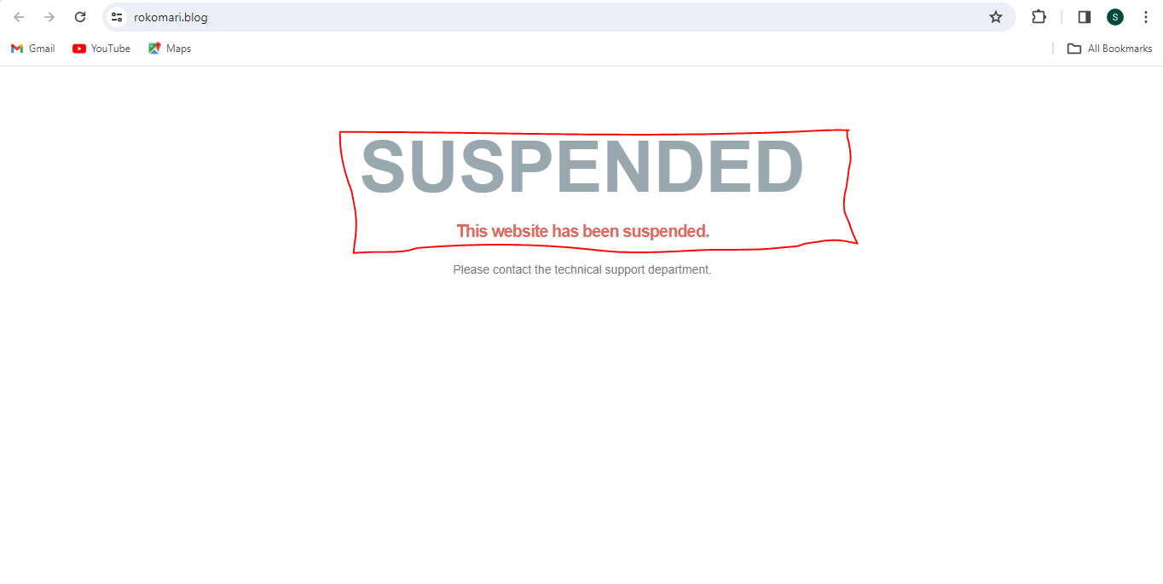

**Description:**

1. Go to the website by searching on <https://www.rokomari.com/book>
2. Click on ব্লগ functionality and you will see “**This website has been suspended”** and the relevant things didn’t visible so it’s a bug.

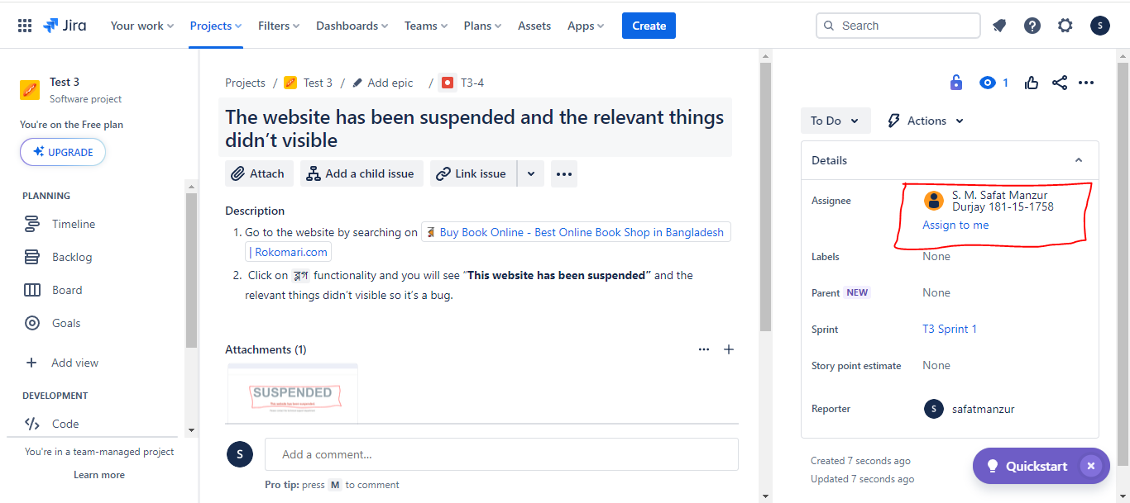

**Description:** The work is assigned to S. M. Safat Manzur Durjay for solving the problem.

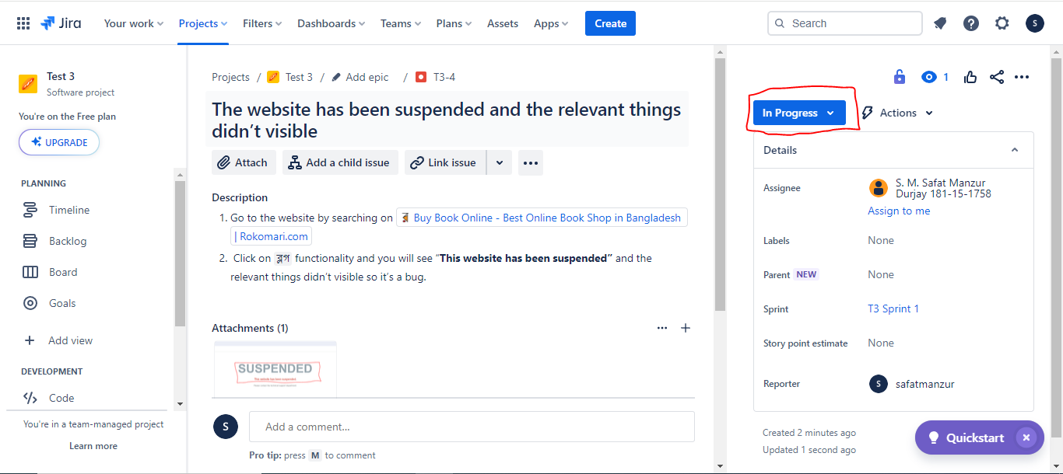

**Description:** The developer started working on it and it was **In Progress** stage.

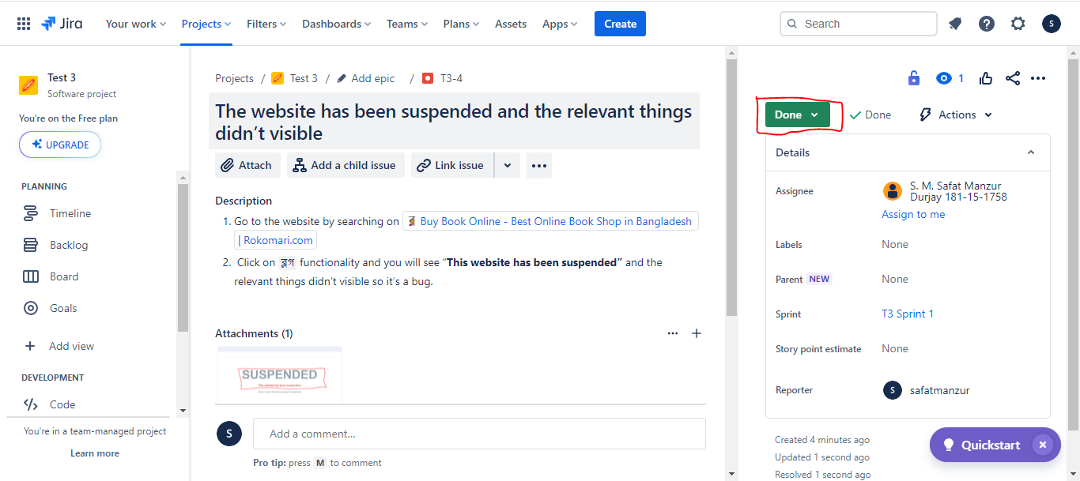

**Description:** The developer completed the work and the work has been **Done**.